Name___________________

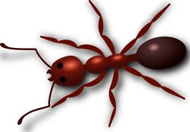

Living Non-Living
Sort the living things you found below here. Sort the non-living things you found below here.

