Living  Record words and pictures about living things below. | Non-Living  Record words and pictures about non-living things below.
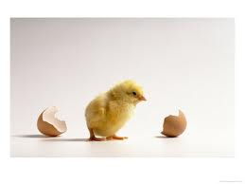  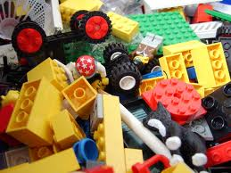  1. __________________________  2. __________________________  3. __________________________ | 1. __________________________  2. __________________________  3. __________________________
Name _____________________________________ Kinder Critters

