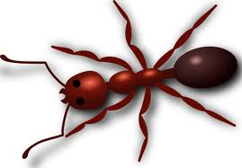

Scavenger Hunt Pictograph

1 2 3 4 5

Living

Non-Living

Which thing did you find the most? ________________________

Which thing did you find the least? ________________________

Name_________________________

